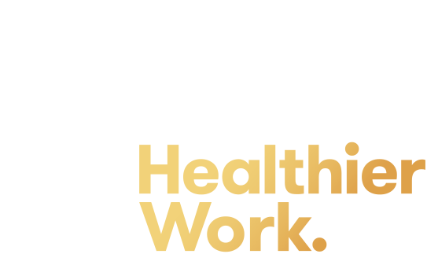

Recognition Application Form
  - July 2023

Healthier Work Annual Application Form

Date: Click or tap to enter a date. | Business Name: Click or tap here to enter text.
Phone: Click or tap here to enter text. |  | Size: Choose an item.
Business Email: Click or tap here to enter text. |  | Website: Click or tap here to enter text.
Sector: Choose an item. |  | Industry: Choose an item.
Street address: Click or tap here to enter text. |  | Postcode: Click or tap here to enter text.
Postal address: Click or tap here to enter text. |  | State: Click or tap here to enter text.
ABN: Click or tap here to enter text.
Key contact name: Click or tap here to enter text. |  | Email: Click or tap here to enter text.
Job title: Click or tap here to enter text. |  | Phone: Click or tap here to enter text.
Which status level are you applying for: Choose an item.
Important Information |  |  | Yes | No
Has the organisation named on this application been issued with any infringement or prohibition notices under the Workplace Health and Safety Act 2011 (ACT) in the last three years? |  |  | ☐ | ☐
Has the organisation named on this application been issued with any infringement or recovery of premium avoidance action in the last three years under the Workers Compensation Act 1951? |  |  | ☐ | ☐
I agree to inform Healthier Work within seven days if the business name associated with the Recognition Scheme becomes the subject of investigation in respect of a breach of the Workplace Health and Safety Act 2011 (ACT) or the Workers Compensation Act 1951. |  |  | ☐ | ☐
Applicants must ensure all relevant insurance, including workers’ compensation and public liability insurance, is current whilst a participant in the Healthier Work Recognition Scheme. If requested by Healthier Work, applicants must provide evidence of the certificate of currency for those insurance policies.
Healthier Work reserves the right to decline or to disqualify, an application at its absolute discretion, including but not limited to situations in which the applicant, or a related person or organisation, has breached or is under investigation for possible breaches of work health and safety laws (whether or not a prosecution is pending), or where the acceptance of the application may otherwise be detrimental to the objectives of Healthier Work or the ACT Government.

Agreement |  | Yes | No
I understand that by reading this completed application form and signing it, I am authorising my business to be considered for Recognition as part of the Healthier Work Recognition Scheme. |  | ☐ | ☐
I give permission for the Healthier Work Recognition Scheme, to use my business name, logo, and photos for promotional purposes through digital media, the Healthier Work website, and other promotional opportunities as they arise. |  | ☐ | ☐
Name (CEO or equivalent):Click or tap here to enter text. | Position:Click or tap here to enter text.
Signature: Click or tap here to enter text.

Date: Click or tap to enter a date.

The next steps
Submit this application form and level requirements documentation to:
Email: healthierwork@act.gov.au
Healthier Work will receipt the arrival of your documents within three working days.
Healthier Work will review your documentation (if applicable) to ensure it satisfies the requirements of the level applied for. If your documentation is not accepted, we will contact you and offer further assistance so you can re-submit the application.
Healthier Work will inform you once we have approved your application for the Recognition Scheme. Renewal of Recognition is required annually and will be set 12 months from the date of approval.
Details of level requirements can be found at healthierwork.act.gov.au

Office use only
Date reviewed: Click or tap to enter a date. | Level assigned: Choose an item.
Plan/documentation submitted: ☐ | Gap assessment completed: ☐
Reviewed by: Click or tap here to enter text. | Position: Click or tap here to enter text.

For further assistance, please
contact the Healthier Work team.
Healthier Work, GPO Box 158, Canberra City,
ACT 2601 or email: healthierwork@act.gov.au
www.healthierwork.act.gov.au | www.act.gov.au

